**Student Research Club!**

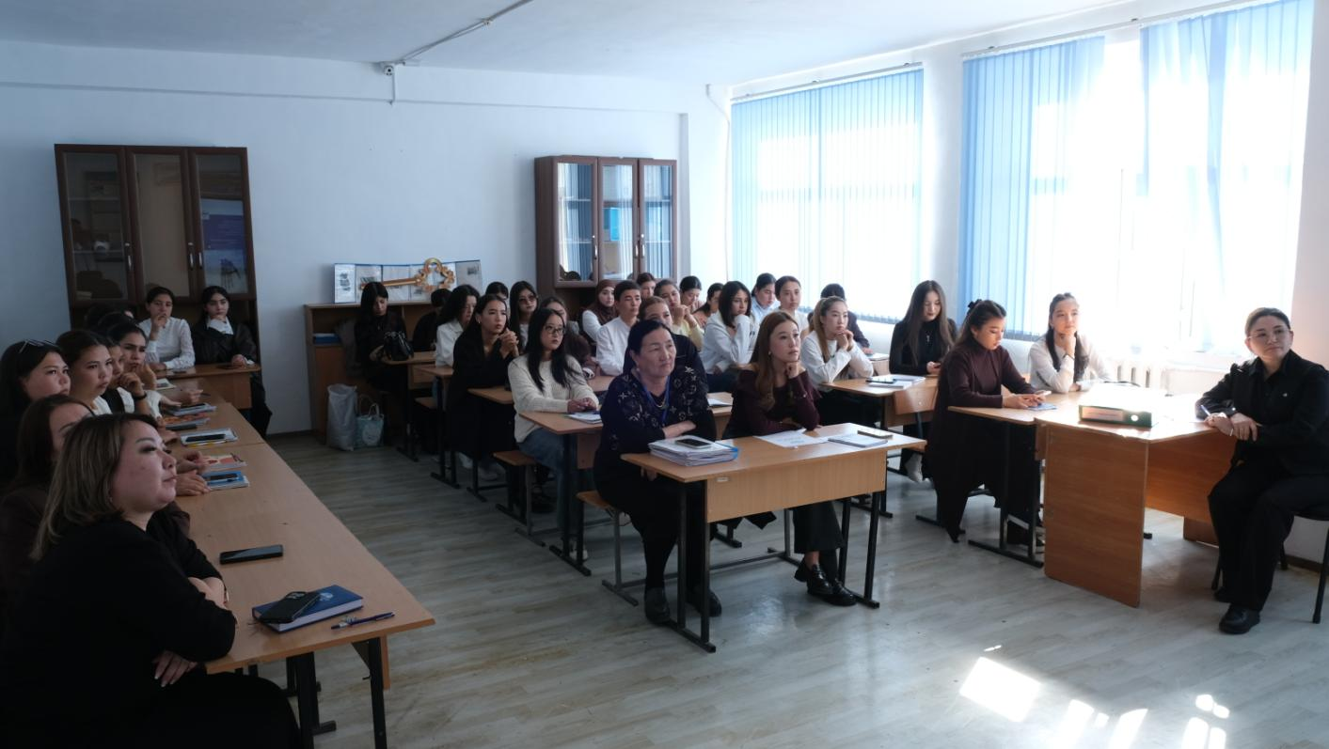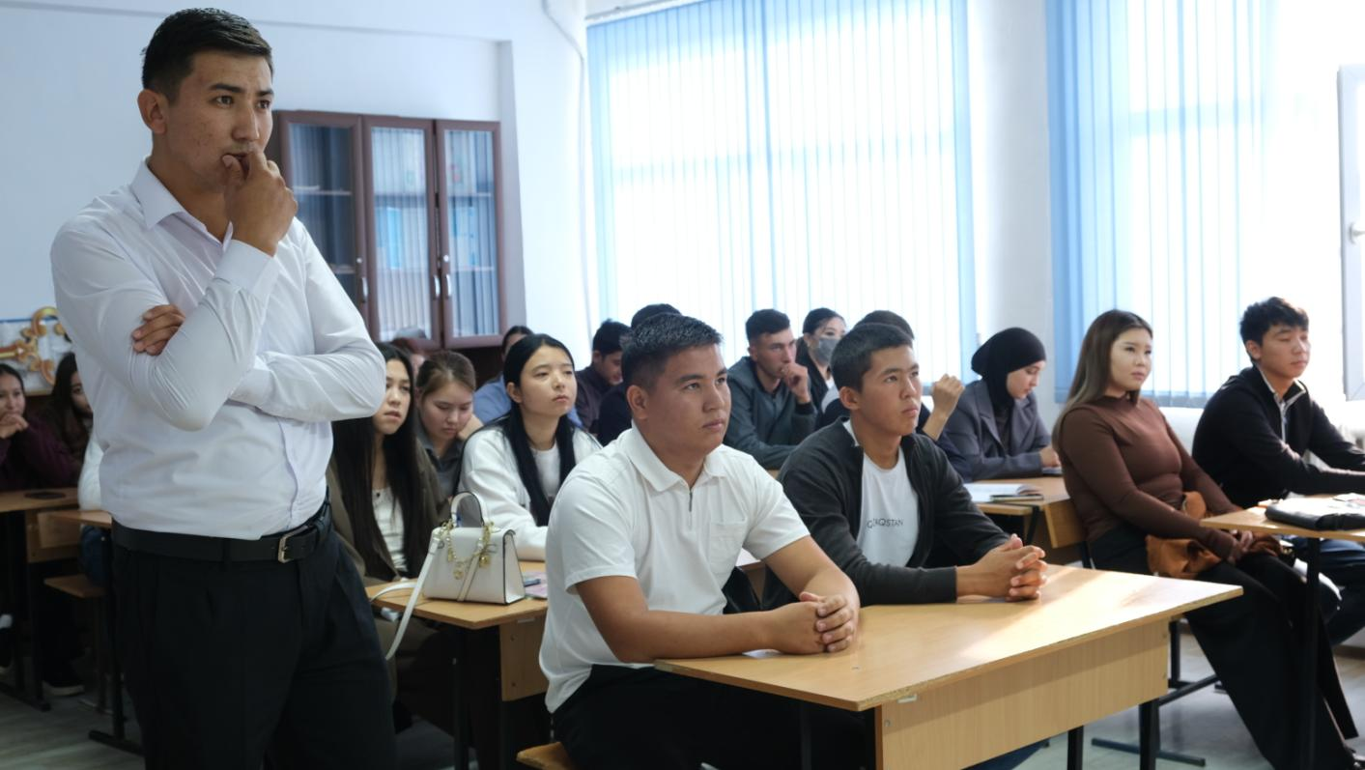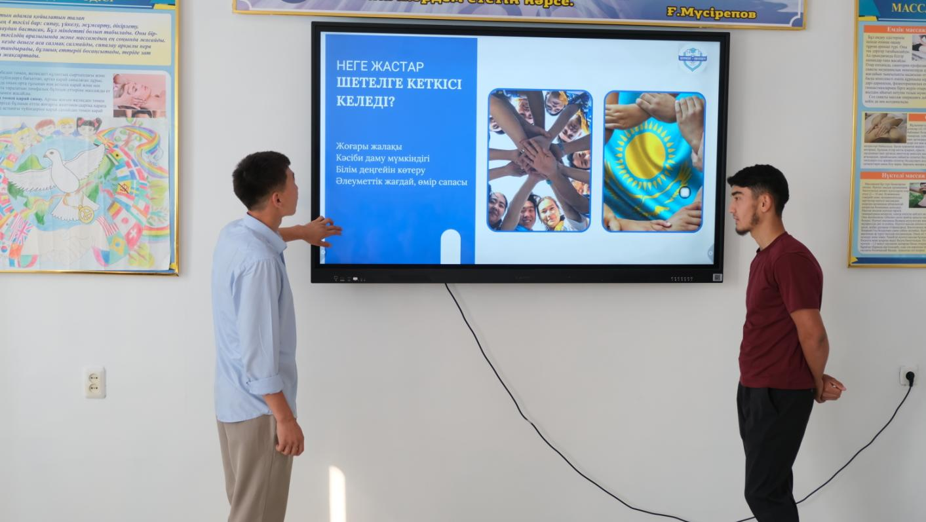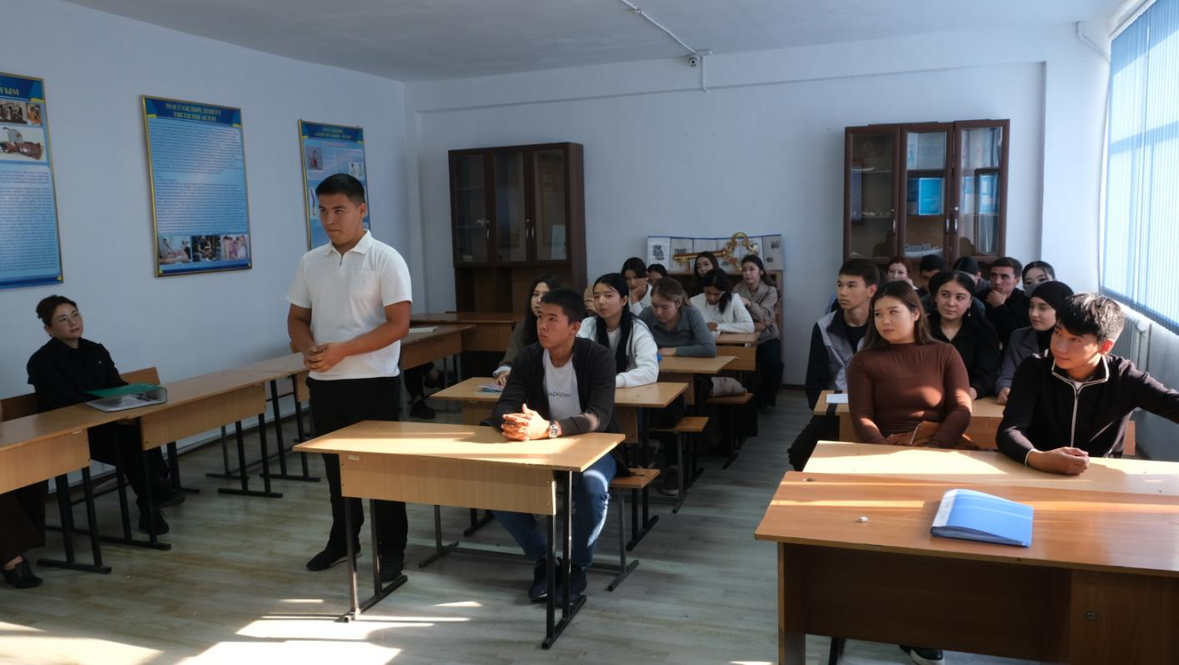On October 1, 2025, Shymkent University hosted meetings of the Q&Tar Club student club from the Faculty of Law and History and the Young Economist Club from the Faculty of Business and Management, in accordance with the Student Research Society's 2025 work plan. At the club meeting, the Q&Tar Club held debates on the topics "Unjust Trials in History" and "The Unjust Path of Kassym Khan," "The History of Legal Reforms (USSR – Modern Kazakhstan)," as well as an essay/article competition on the topic "Where to Look for Justice?" and intellectual games. The Young Economist Club presented reports on the topics "Is Education Worth Spending? The Return on Investment in a Degree" and "Kazakhstani Youth in the Global Labor Market: To Leave or to Stay?", and also organized a Q&A session and discussion.

